MMP_5_ICC INDIVIDUAL ESSAY
Student ID: S4240131

The Role of Mindfulness in Marketing Communications
Part A: Introduction
Mindfulness, defined as “moment-by-moment awareness of thoughts, feelings, and the surrounding environment” (Kumar et al., 2024, p. 978), has become a central concept in contemporary marketing. While initially linked to wellness and Eastern philosophical traditions, mindfulness is now a commercial strategy used in modern day to forge deeper connections between brands and consumers. Johnson et al. (2009) argues that mindfulness heightens positive emotions, promoting self-awareness, empathy, and environmental consciousness – qualities that are increasingly valued in consumer culture. This shift reflects a growing consumer preference for authenticity, ethical production, and emotional resonance, particular in a contemporary era where brand loyalty is often fragile.
The role of mindfulness in marketing communication extends beyond abstract principles. It manifests through sensory engagement, symbolic alignment, and identity-driven branding. By tapping into the psychological and emotional states of consumers, brands like Pangaia and Barbie have transformed consumer-brand relationships. This essay critically examines the role of mindfulness in marketing communication, analysing its theoretical foundations and strategic applications. Using the 2023 Barbie movie campaign as a case study, the essay illustrates how sensory marketing, symbolic triads, and interactional models were used to enhance engagement, drive cultural relevance, and build emotional connections.
Part B: Literature Review Conceptualizing Mindfulness in Marketing
Mindfulness in marketing can be understood through its emphasis on present-moment awareness and emotional self-regulation. Brown, Ryan, and Creswell (2007) conceptualize mindfulness as a “receptive attention to current events, realities, and experiences,” which fosters greater self-control and attentional capacity. This definition is pivotal to marketing communications as it influences consumer attention, perception, and decision-making. Weil (1989) further argues that Western consumers are particularly receptive to mindfulness due to its alignment with self-care, sustainability, and wellness trends.
However, existing definitions of mindfulness in marketing are limited in scope. Much of the foundational research was conducted in specific contexts, such as healthcare (Australia and Malaysia) or consumer behaviour in Western economies. These regional and cultural constraints call into question the generalisability of existing studies. This is significant, as consumer behaviour has evolved in response to globalisation, social media, and the increased digitisation of brand-consumer interactions. As such, further research is needed to assess whether “mindfulness” operates differently across diverse consumer demographics. Research by Stuart et al. 1987 does indicate that the exponential of classical conditioning through symbolic triads are more successful with new products/brands compared to familiar of mature products/brands, which have already been exposed to the public. Therefore if brands attempt to emotively associate ideas foreign to the stimuli presented, this may reduce the feeling of authenticity within their campaign efforts, possibly opposing prior thoughts and leading to confusion.
Integration of Mindfulness in Marketing Strategies
The integration of mindfulness into advertising has shifted from wellness associations to comprehensive strategic marketing. Blackwell’s Consumer Decision Process (CDP) model underscores the growing importance of individual differences in consumer behaviour, aligning the personalised aspect of mindfulness potently. Blackwell does this by aligning the principles of mindfulness as a personalised, subjective experience. Mindful marketing strategies increasingly prioritise ethical messaging and symbolic meaning to differentiate brands from competitors.

An illustrative example is Pangaia’s collaboration with Headspace for World Mental Health Day 2023. This campaign combined mindfulness with sustainable fashion, offering consumers access to Headspace’s mindfulness resources alongside ethically produced products. Charles Sanders Peirce’s symbolic triad (object, sign, interpretant) is a useful theoretical lens to analyse this strategy. Here, Pangaia’s products (object) were paired with visual cues of nature (sign) to create a symbolic narrative of “conscious consumption” (interpretant). This alignment appeals to consumers’ desire for ethical, mindful living, reinforcing Pangaia’s brand position as a leader in sustainable fashion.
Sensory Marketing and Emotional Resonance
Mindfulness plays a pivotal role in sensory marketing, as sensory cues elicit present-moment awareness. Errmann (2024) argues that sensory marketing relies on multi-sensory engagement (sight, sound, touch, taste, and smell) to create lasting brand impressions. This strategy is seen in Coca-Cola’s iconic “fizz” sound or the diffused “Stefan Floridian Waters” scent used by Singapore Airlines within cabins, lounges and offices. These are examples of mediums that combine sensory engagement with emotional experiences. Using this, brands can foster further emotional recall and positive brand associations
Furthermore, Banister and Hogg (2024) posit that sensory marketing is particularly effective when it is linked to the consumer’s self-concept. Products are often perceived as symbols of identity, and consumers purchase items that reinforce their ideal self-image. This insight underpins the symbolic alignment found in sensory-driven campaigns. For example, brands like Chanel or Apple create sensory experiences that symbolise luxury, aspiration, and sophistication — elements that become integral to the consumer’s self-identity.
Part C: Analysis of the Barbie Movie Campaign (2023) Positioning and Brand Identity
The Barbie movie campaign in 2023 demonstrates the power of mindfulness-driven marketing. Traditionally associated with children’s toys, Barbie was repositioned as a symbol of modern womanhood, individuality, and self-expression. The campaign’s objective was to foster a deeper emotional connection with audiences, prompting reflection on themes of identity and empowerment. By leveraging Barbie’s nostalgic cultural presence, Mattel recontextualized the brand for adult consumers, embedding mindfulness principles into its core messaging.
One notable technique was the use of ‘identity congruence’, where consumers align their self- identity with the brand’s symbolic meaning. By showcasing diverse Barbies with varying body types, careers, and personalities, the campaign reflected societal conversations around inclusion and representation. This was not just a symbolic gesture but a strategic application of mindfulness, encouraging consumers to reflect on their own individuality in the context of a shared cultural experience.
Application of AIDA and Sensory Marketing
The AIDA model — Attention, Interest, Desire, and Action — is a foundational marketing tool, and its application is evident in Barbie’s campaign. ‘Attention’ was captured through striking visuals, including Barbie-themed billboards, pink-branded packaging, and vibrant OOH advertising. Due to the extensive history of the Barbie brand, which first launched in 1959, the iconic “Barbie pink” colour serves as a symbolic trigger for nostalgia, recalling childhood memories. Through the frequent classical conditioning of Barbie’s motifs. This ‘Interest’ was cultivated through high-profile collaborations with brands like Zara, OPI, and NYX, further broadening Barbie’s appeal.

The creation of Barbie World by Ice Spice and Nicki Minaj illustrates the role of sensory marketing in shaping emotional experience. The auditory engagement created by the song amplified brand recognition. Belk (1991) suggests that personal possessions act as materialised memory, which is particularly relevant to Barbie. By tying the auditory cue of “Barbie World” to visual marketing (e.g., TikTok challenges), the campaign achieved cross-sensory resonance, thereby reinforcing Barbie’s presence across platforms. Plus the implementation of influencer (two-step) model by inviting opinion leaders like Saffron Barker, and Opinion leaders like Nicki Minaj and Dua Lipa to the movie premier to once again heighten interest and desire to support this campaign. McCracken, 1989;and Till et al., 2008 believe this growth in interest through ‘meaning- transfer’. The integration of these forms of communication alluded to clear calls to action for interaction and attendance. The success of the campaigning efforts were historic, opening week the movie generated $356m the opening weekend around the world (The Guardian, 2023). Interestingly according to PostTrack, Women made up 65% of the audience, with 40% of ticket buyers under the age of 25.
The Interactional Model and Barbenheimer Phenomenon
One of the most compelling aspects of the Barbie campaign was the “Barbenheimer” cultural phenomenon, which occurred as Barbie’s release coincided with the release of Christopher Nolan’s Oppenheimer. While initially seen as a release date clash, it evolved into a synergistic cultural moment. Vavre (2015) notes that Generation Y and Z seek “educational engagement” in consumer decisions, and Barbenheimer exemplified this by sparking debates on social media platforms.
This phenomenon reflects the Interactional Model of Communication, as it created a feedback loop between brand and consumer encouraging organic, peer-to-peer discussion. The playful juxtaposition of Barbie’s whimsy against Oppenheimer’s intensity fuelled global conversations, subsequently enhancing brand visibility. The cultural currency of “Barbenheimer” is an example of “accidental virality” — a concept that has yet to be thoroughly explored in marketing literature. It also demonstrates how brands can benefit from unplanned cultural synergy, pointing to the unpredictable power of consumer-driven narratives.
Sensory Engagement and Nostalgia
Mindfulness was embedded in the Barbie campaign through sensory engagement and nostalgia. The colour pink, symbolic of Barbie, was used throughout marketing materials, creating a perceptual cue for instant brand recognition. Belk’s (1991) argument that possessions materialise memory applies directly here; by engaging consumers’ childhood memories of Barbie, the campaign connected past and present selves, aligning with mindfulness principles of present-moment reflection.
Conclusion
The integration of mindfulness into marketing communications represents a shift from transactional advertising to emotionally resonant, consumer-centric storytelling. By incorporating mindfulness into advertising models like AIDA, sensory marketing, and symbolic triads, brands can create meaningful connections with consumers. The Barbie campaign demonstrates how nostalgia, sensory engagement, and symbolic congruence can be harnessed to foster emotional bonds. Beyond commercial success, the campaign’s impact on cultural discourse highlights the transformative potential of mindful marketing. By blending commercial strategy with social commentary, Barbie reasserted itself as both a cultural icon and a commercial juggernaut, setting a new benchmark for mindful marketing in practice. The evident contrast to Pangaia’s strategy depicts how various implementations of mindfulness can resonate with consumers and yield success.

Appendix 1 – Sensory Marketing Frameworks

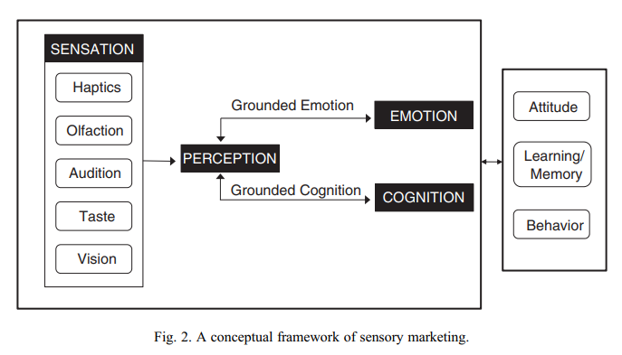

Appendix 2 – Consumer Decision Making Frameworks
Figure 1 – Types of Behavioural and Cognitive learning (Fill & Turnbull, 2019)
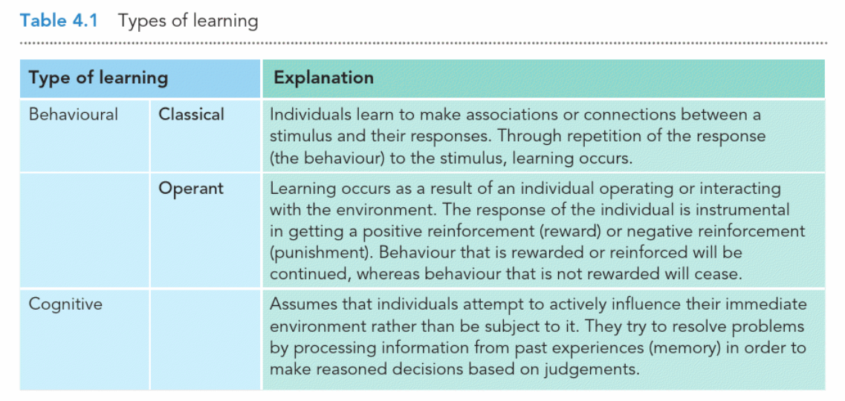

Figure 3 – Sequential models of marketing communications.

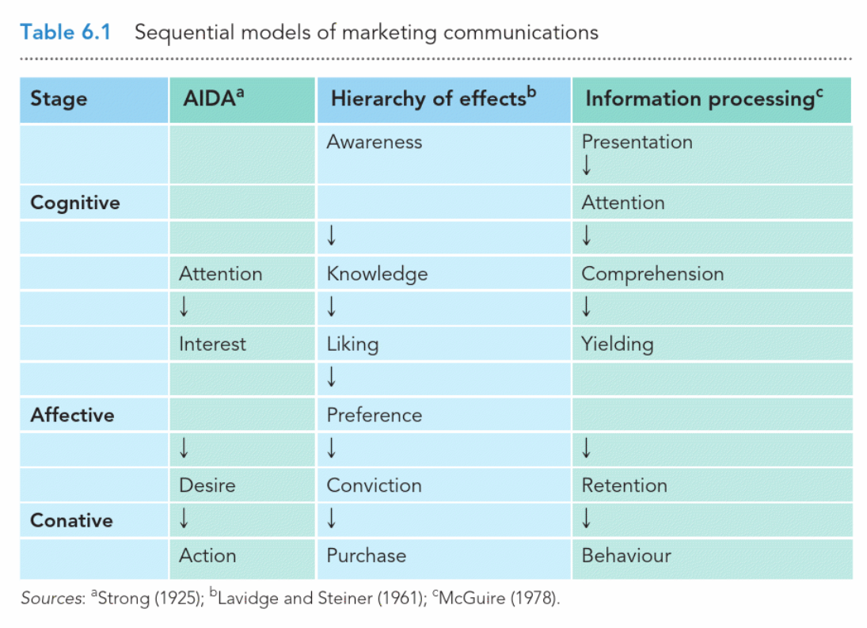

Appendix 3 – Examples of Sensory Cues in Marcomm

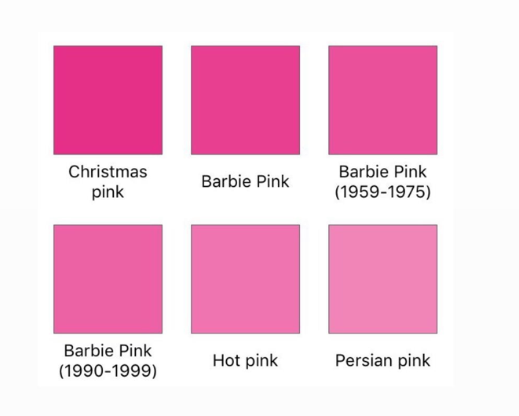

Figure 4 displays the evolution of ‘Barbie pink’ in comparison to popular hues of pink. Barbie’s pink has drawn closer to the Christmas pink, and further from hot pink. Barbie’s developed association with a specific colour has enabled visual cues within various campaigns to feel organically interlinked.



Figure 5 – Above the Line Marketing.
Within the campaign, Barbie combined technological advancements to create awe-inducing stimulations beside the world’s tallest skyscraper Burj Khalifa. Burj Khalifa is a central location for tourism being at the heart of Dubai, positioning advertisement for Barbie here, exponentially increases the reach and awareness to the movie.

Buses across the world were also spotted fully wrapped in Barbie advertisement. Featuring ‘Barbie pink’ their signature visual cue combined with the famous lead characters of the movie, Margot Robbie and Ryan Gosling.

Appendix 4 – Media Outlets
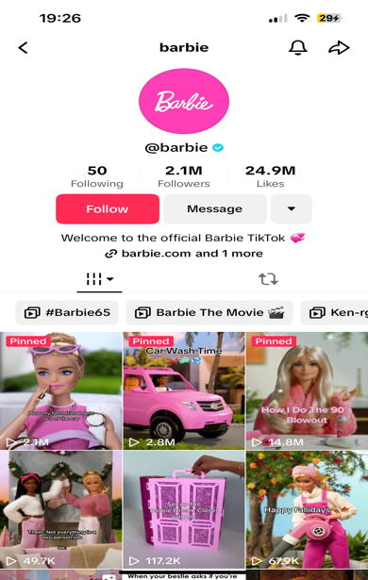
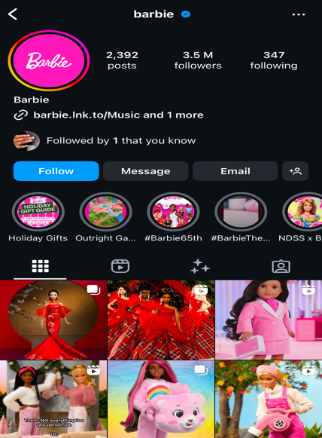

OWNED/EARNED MEDIA - Figure 6 (on the left), Tiktok following and engagement Figure 7 (on the right), Instagram presence.




Appendix 5 – Barbenheimer Phenomenon – Interactive Model

Figure 8 (left) shows the clash of both movies’ OOH marketing. Figure 9 (right) displays an interview including the leading actors of both movie, encouraging more conversation and competition.

In Figure 10, there’s a display of how consumers can interact with Barbie’s advertising efforts in an interactive, memory evoking manner.

Appendix 6 – Influencer Marketing

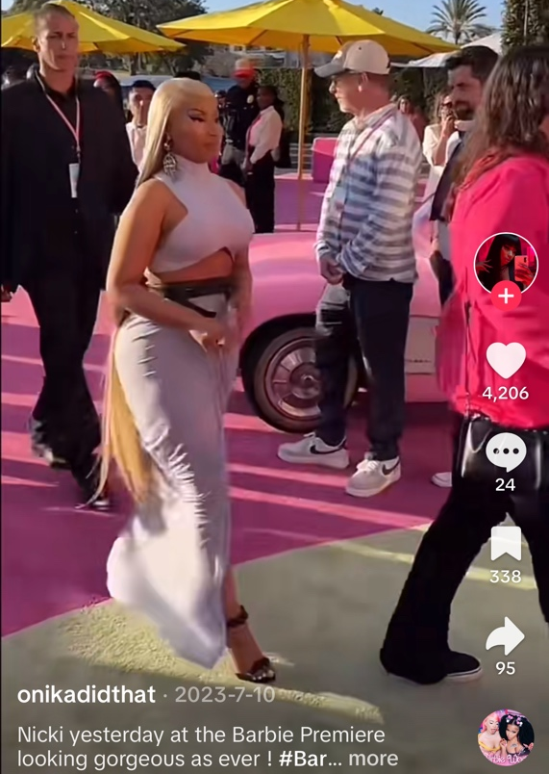

Figure 11 (left) and figure 12 (right), influencers are shown preparing and attending the Barbie premiere. Once again, messaging ideas of meaning transfer through their appearances.

References

Errmann, A. (2024). Mindful Immersion: Curating Awe Inducing Experiences to Increase Brand Salience. Journal of Advertising, 1-15. https://doi.org/10.1080/00913367.2024.2325144(Accessed: 15 December 2024)

TheGuardian, (2023). Barbie smashes box office records for a film directed by a woman. https://www.theguardian.com/film/2023/jul/24/barbie-movie-box-office-greta-gerwig-records-highest-grossing-woman. (Accessed: 15 December 2024)

Brown, S., Kozinets, R.V. and Sherry Jr., J.F. (2003) Teaching Old Brands New Tricks: Retro Branding and the Revival of Brand Meaning. Journal of Marketing, 67, 19-33.
https://doi.org/10.1509/jmkg.67.3.19.18657. (Accessed: 15 December 2024)

Slootweg, E. and Rowson, B. (2018) ‘My generation: A review of marketing strategies on different age groups’, Research in Hospitality Management, 8(2), pp. 85-92. https://doi.org/10.1080/22243534.2018.1553369 (Accessed: 15 December 2024)

Brown, S., Kozinets, R.V. and Sherry, J.F. (2003) ‘Teaching old brands new tricks: Retro branding and the revival of brand meaning’, Journal of Consumer Research, 67(2), pp. 19–32. Available at: https://doi.org/10.1002/mar.20691(Accessed: 15 December 2024)

Zahid, N.M., Khan, J. & Tao, M. Exploring mindful consumption, ego involvement, and social norms influencing second-hand clothing purchase. Curr Psychol 42, 13960–13974 (2023). https://doi.org/10.1007/s12144-021-02657-9(Accessed: 15 December 2024)

Wells, VK (2015) Behavioural psychology, marketing and consumer behaviour: a literature review and future research agenda. Journal of Marketing Management. pp. 1119-1158. ISSN 0267-257X. https://doi.org/10.1080/0267257X.2014.929161.(Accessed: 15 December 2024)

